***Special facilities provided for women in terms of***

1. **Safety and Security**

 Deployment of security personnel at entry points of college. Entry in the College campus without valid I-Cards is prohibited. There is substantial CCTV surveillance in the college campus. Further, the staff members carry out proctorial duties in their respective blocks to keep a check on unwanted activities.

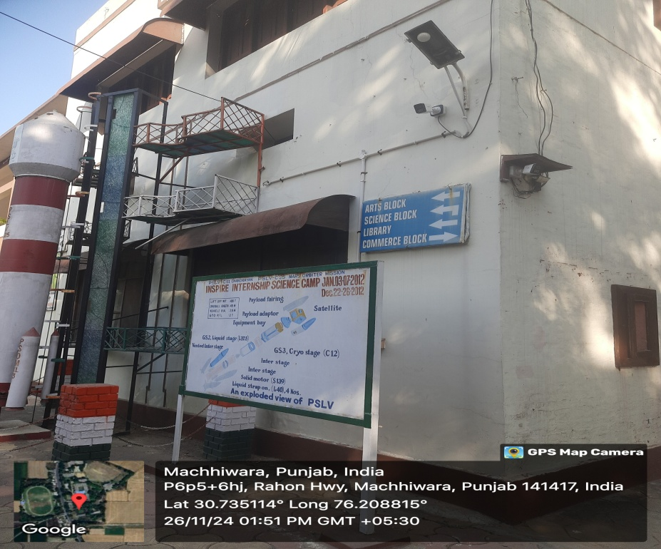

**CCTV surveillance**

1. **Anti Sexual Harassment Committee under Sexual Harassment of women at work place (Prevention, Prohibition, Redressal) Act,2013 –**

The committee is formed to address the grievances of the female students and staff. Information about the committee is displayed in girl’s common room. Relevant information regarding this has also been made available on college website.

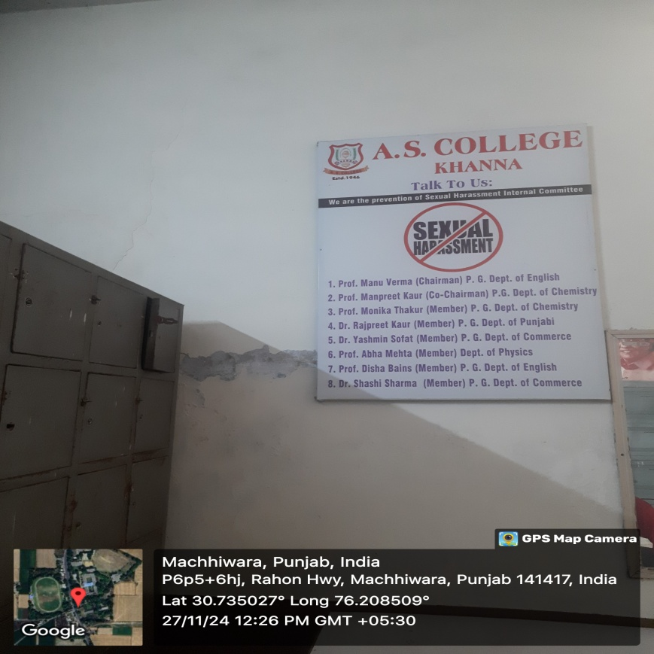

**Anti Sexual Harassment Committee**

1. **Women Empowerment cell-** The cell has been constituted in the college to raise awareness about women’s issues, promote gender equality and to offer support such as personal guidance and counseling to the female students. Various placards have been displayed by the cell in the campus to create awareness about sexual harassment among women.

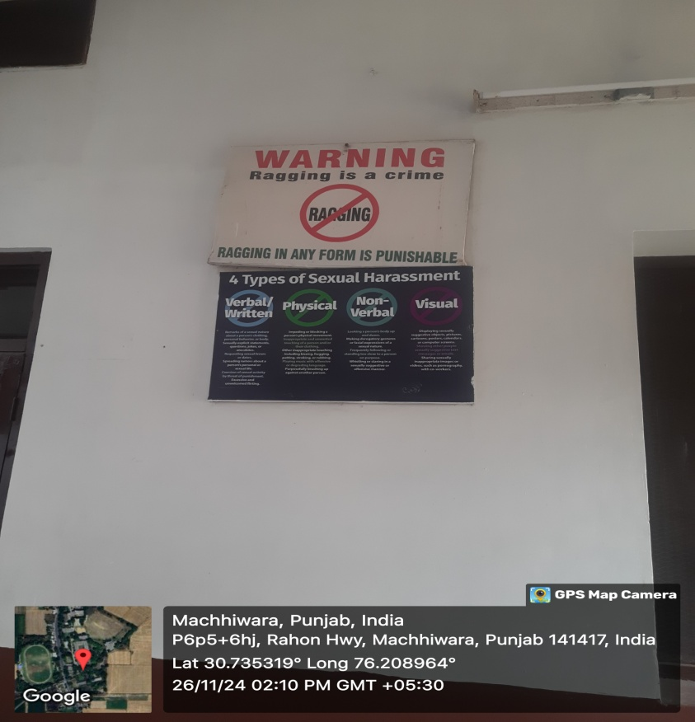

**Placards displayed in the campus to create awareness about sexual harassment among women.**

1. **Anti-Ragging Committee:** Information regarding the committee is made available in prospectus and on the institutional website
2. **Common Room for girls:** The institute provides the facility of two common rooms for girls. All the blocks have separate wash rooms for women students. Also, separate areas in the college library and canteen have been provided to the girl students for their comfort and convenience.

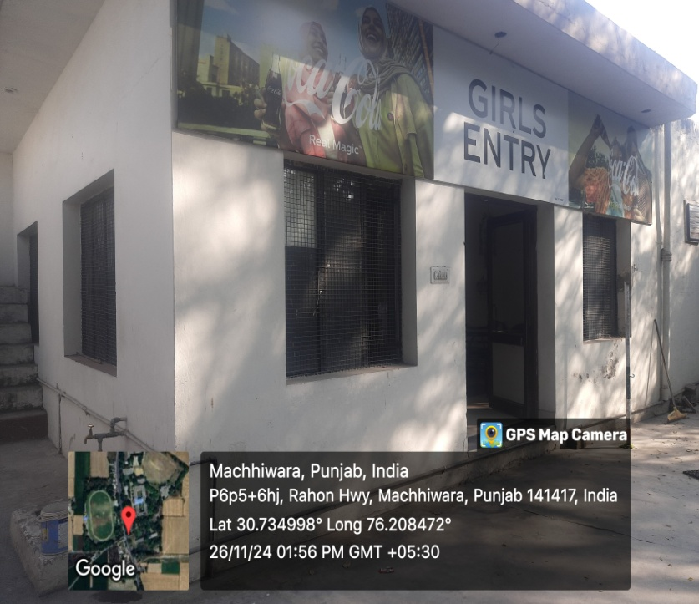

**Girl’s entry to college canteen**

1. **A special orientation/assembly for girl students** is organized at the start of the session to provide a requisite platform to the girl students to share their experiences and also to elevate their academic, social as well as financial skills.
2. **Sanitary Pad Vending Machine:** For the convenience of girl students, a sanitary pad vending machine and an Incinerator for pad disposal are installed in girl’s common room.

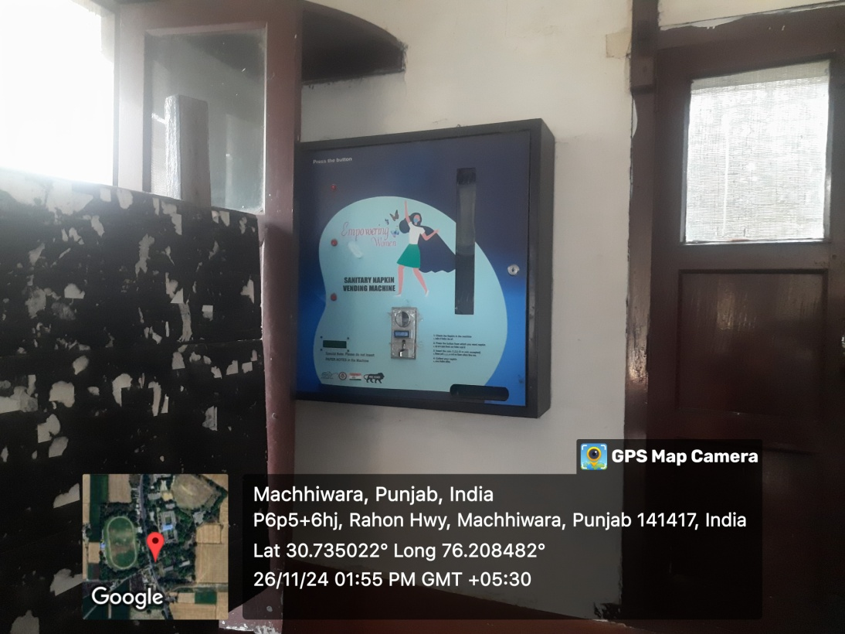

**Sanitory Pad vending Machine in girl’s common room**

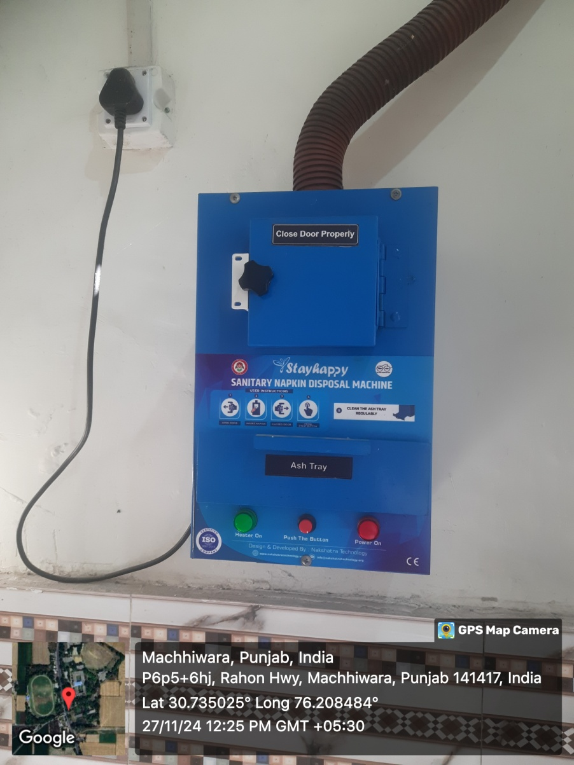

**Incinerator for pad disposal**